
March monthly report
……..........................................................
Dr. Pongkarn Chakthranont
Sothearoth Heng
NCR ID: 803198
Under the supervision of
Dr. Pongkarn Chakthranont
Contract Number: NCR-NN-2023-20170-EN
March 2024
Project Title:
Development of Cu-based catalyst for electrochemical CO₂ reduction to C₂ products: combined computational chemistry and electrochemical engineering approach

- Tasks list for March
- Investigation of eCO2RR performance under higher CO₂ flow rate (100-200ml/min) using sputtered Ag cathode
- Screening the eCO2RR performance of different single-atom catalysts (Co, Cu, Fe, Zn, and Ni-2D-NOC) under CO₂ gas stream of 150ml/min and j of 200mA/cm²
- Synthesis of Ni-2D-NOC catalyst via pyrolysis method under Argon gas.
- Studies of influence of varied cathodic gas feed compositions on CO selectivity:
  - Absolute CO₂ supply (15, 30, 100, 150 ml/min)
  - Gas mixture of 15%CO₂/85%N₂ (total flow rate of 100ml/min)
  - Gas mixture of 95%CO₂/5%O₂ (total flow rate of 100ml/min)
- Experimental Procedure
Synthesis of Ni-2D-NOC catalyst via pyrolysis method
The synthesis of Ni-2D-NOC catalyst was completely followed the previous report.¹ Initially, Ni-Phc, Urea, and Dicy (weight ratio of 1:5:5) were ground-mixed thoroughly together. Then, the mixture was placed in a quartz boat that was closed with a lid and pyrolyzed at 800 °C (ramp rate = 10 °C·min^{–1}) in a tube furnace under an Ar atmosphere (flow rate = 200 sccm) for 2h.

Preparation of Ni-2D-NOC cathode electrodes via spray coating method
The as-prepared Ni-2D-NOC catalyst was spray-coated onto Sigracet 36BB carbon paper. Briefly, 50 mg of the Ni-2D-NOC and 127µL or 10% by catalyst weight of XA-9 Binder were ultrasonically mixed with IPA for 30 min to form a dark colloidal solution which then was sprayed onto carbon paper with 0.5 ml/min on 95 °C hotplate to obtain ~ 0.5 ± 0.15 mg/cm².

Electrochemical CO2RR measurements
A 5 cm² MEA electrolyzer was used to evaluate the CO2RR performance under modulated operating conditions. The Ni foam, AEM (X37-50 Grade RT, Dioxide Materials), and sputtered Ag and M-2D-NOC (M denoted as Co, Cu, Fe, Zn, and Ni) cathode catalysts were employed as the anode, membrane, and cathode electrode, respectively. 50 ml of 0.5M KOH was recirculated and used throughout the experiment as the anolyte at 8 ml/min. Different humidified gas feed compositions was introduced into the cathodic inlet under various flow rates. The cathodic outlet was directly injected into an online gas-chromatography for further gas products analysis.

- Results
Influence of CO₂ flow rate on eCO2RR performance of sputtered Ag cathode
In the previous report, we had conducted CO2RR at 5-50 mlCO₂/min and proved that the FE(CO) was CO₂ flow rate dependent with a maximum FE(CO) of 76% at 30 mlCO₂/min. To further extend the understanding of the influence of higher absolute CO₂ amounts, the CO2RR performance of the sputtered Ag was conducted at 100-200 mlCO₂/min. As shown in Fig. 1, we observed a slight raise in FE(CO) with approx. 5% of FE(H₂) at 100 mlCO₂/min comparing to 30 mlCO₂/min. By further elevating the CO₂ flow rate to 150 mlCO₂/min, the CO selectivity was drastically boosted in terms of achieving higher FE(CO) of approx. 89% with 5% FE(H₂), and reaching the equilibrium at 200 mlCO₂/min. These results demonstrated that the decreased kinetic of CO2RR at lower CO₂ supply might be attributed to the CO₂ deficiency on the catalytic active site of Ag which can be solved by increasing the CO₂ flow rate.²

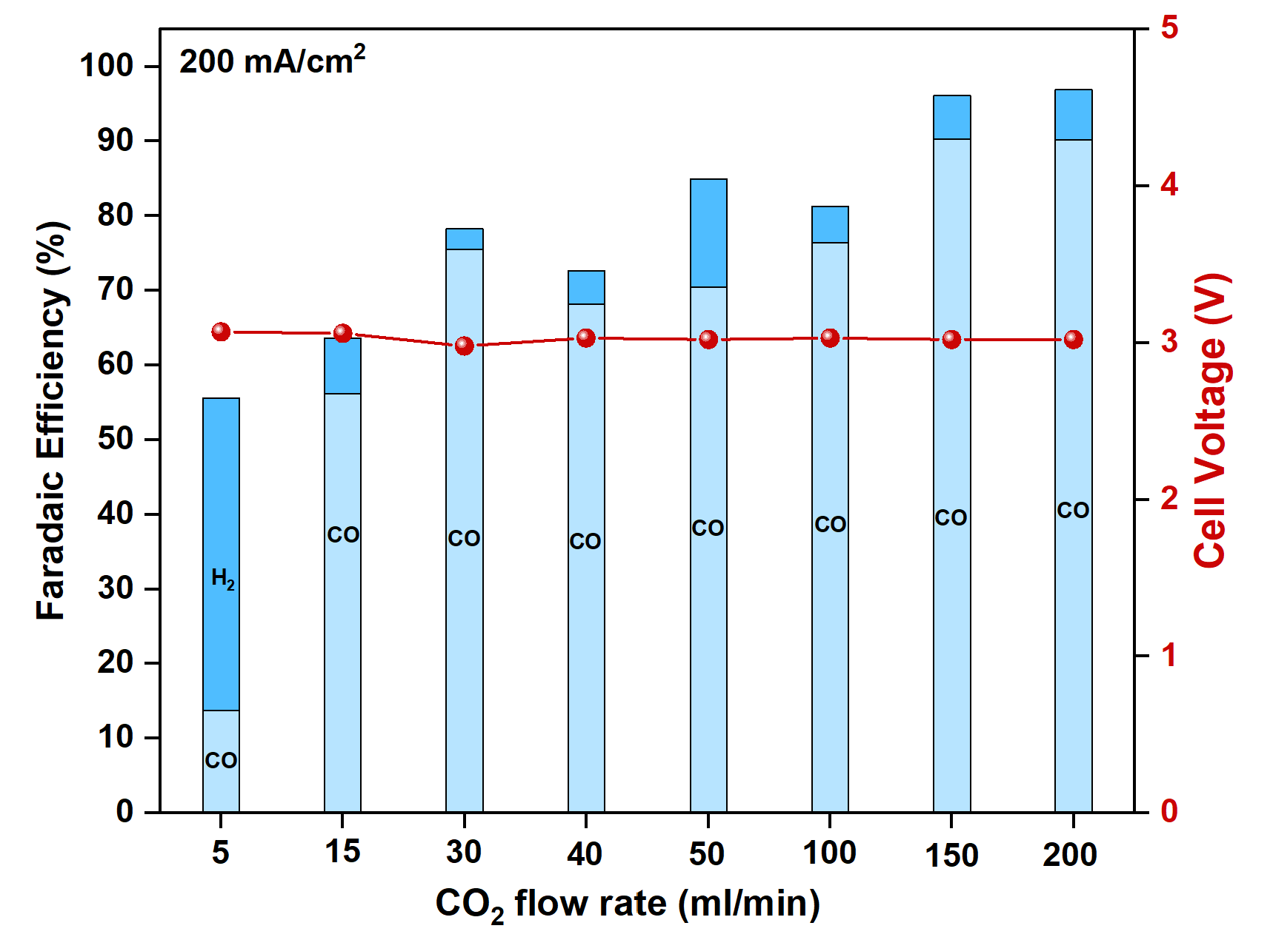
Figure 1. Faradaic efficiency of the MEA electrolyzer with sputtered Ag cathode under CO₂ flow rate range of 5-200 ml/min at 200mA/cm².

Influence of different cathodic gas feed compositions on CO selectivity of Ni-2D-NOC cathode catalyst
The CO2RR was performed at various absolute CO₂ flow rate (15, 30, 100, and 150 ml/min), j of 200mA/cm², and 0.5M KOH anolyte flow rate of 8 ml/min to identify the effect of CO₂ supply on overall MEA performance. A similar trend of poor CO selectivity to sputtered Ag was also noticed in Ni-2D-NOC cathode catalyst in which the current densities of both sputtered Ag and Ni-2D-NOC cathodes, whose FE(H₂) drastically increased at low-CO₂ supply, were strongly influenced by a competitive HER on the active sites due to the scarcity of surface-adsorbed CO₂. By further raising the amount of CO₂ from 15 to 30, 100, and 150 ml/min, the FE(CO) was exponentially increased with a maximum FE(CO) of approx. 98% at CO₂ supply of 150 ml/min, suggesting that the CO₂ to CO performance of Ni-2D-NOC catalyst was prone to correlating with the amount of CO₂. On the other hand, the direct conversion of low concentrated CO₂ feed is crucial for practical application with a direct flue gas that mainly contains of 5-40% CO₂ balanced by N₂ with trace amount of O₂ as the feedstock. (18 in low C). Diluted 15% CO₂/N₂ and 95%CO₂/5%O₂ gas mixtures were used as cathodic gas feed to determine the effect of low-concentrated CO₂ feed or low-P_{CO2} (CO₂ partial pressure) and competitiveness of oxygen reduction reaction (ORR) on CO selectivity of the MEA electrolyzer, respectively. As can be seen in Fig. 2, for a 15%CO₂/N₂ gas feed, the CO selectivity exhibited a similar trend with absolute CO₂ flow rate of 15 ml/min but even poorer CO2RR performance due to lower CO₂ concentration could lead to higher competing HER on the catalytic active sites (extrinsic factors, such as anolyte flow rate or water crossover management might play an essential role to suppress HER activity at low-P_{CO2}).^{3–5} The oxygen reduction reaction (ORR) is a known catalytic reaction that can occur under reducing potentials and is thermodynamically more favorable than CO2RR to CO.⁶ In the presence of 5%O₂ in 95%CO₂ cathodic gas feed, CO2RR performance and total faradaic efficiency were significantly detrimental by ORR activity. The CO selectivity was completely fell off after 1h of operating duration, suggested that high water content produced by ORR activity at the cathode surface could possibly enhance a competing HER activity and cause GDE flooding.

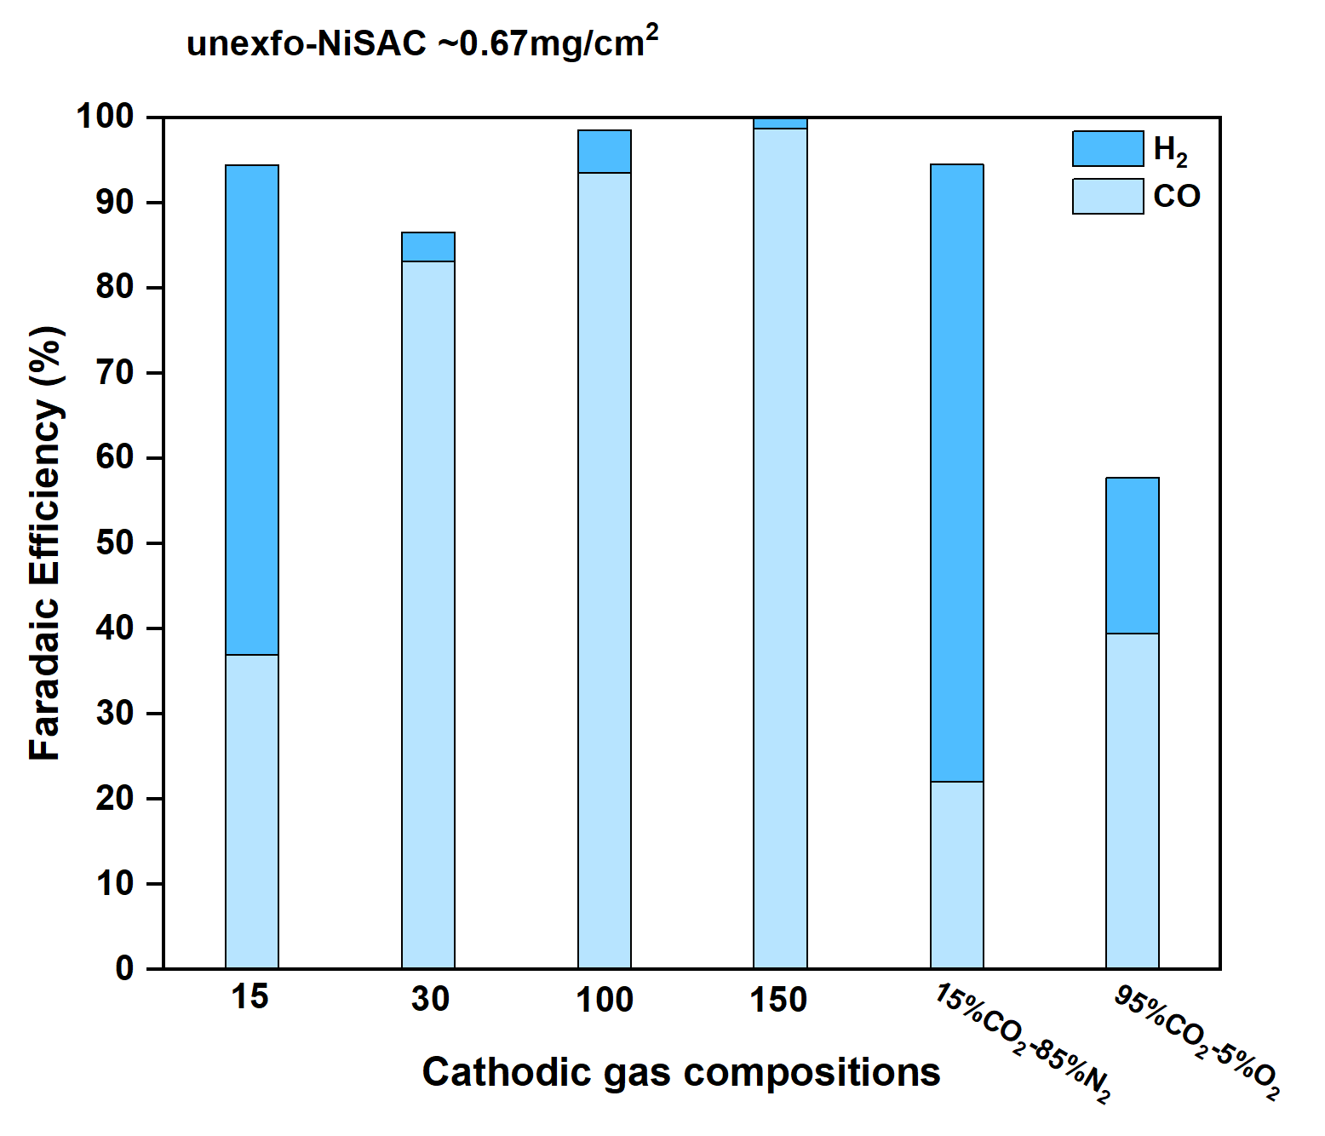
Figure 2. Faradaic Efficiency of MEA electrolyzer with Ni-2D-NOC cathode under 200mA/cm² and different cathodic gas compositions (15-150 mlCO₂/min, 15%CO₂/N₂, and 95%CO₂/O₂).
CO2RR performance of different cathode materials
The CO2RR performance of different Ag-based catalysts and M-2D-NOC single atom catalysts was prescreened under 200mA/cm² and 150mlCO₂/min. As shown in Fig. 3, Ag-based cathode catalysts exhibited a high CO selectivity in terms of achieving a maximum FE(CO) of approx. 89% with a slight H₂ byproduct. Meanwhile, most of as-prepared and exfoliated-M-2D NOC single atom catalysts (M = Co, Zn, Ni, Fe, and Cu), except the as-prepared Ni-2D-NOC, strongly suffered from the GDE flooding due to their high hydrophilicity, proton affinity, and catalytic HER which could lead to suppress CO2RR performance. On the other hands, the catalytic performance of Ni-2D-NOC seems unaffected by HER, showing superior CO₂ to CO activity compared to other materials, with a maximum FE(CO) of approx. 98%.

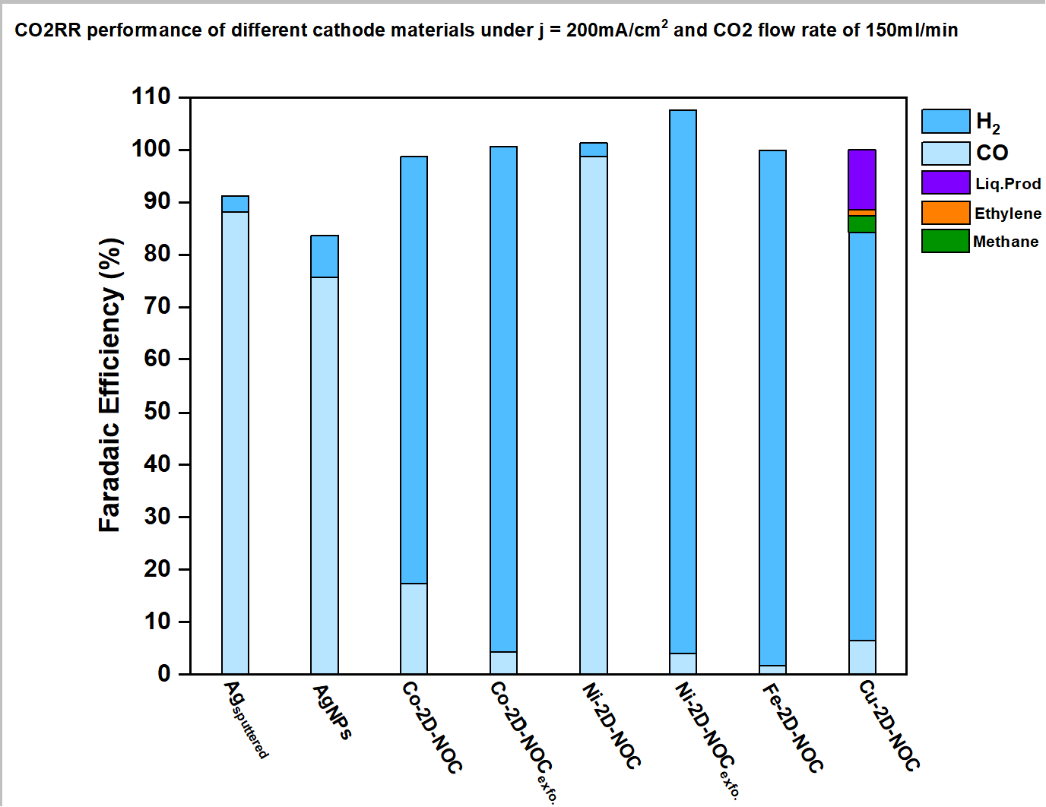
Figure 3. Faradaic efficiency of different cathode materials under applied current density of 200mA/cm² and 150 mlCO₂/min.

- Summary
In summary, both sputtered Ag and Ni-2D-NOC cathode catalysts showed improved CO2RR performance when the absolute amount of CO₂ was increased. However, the Ni-2D-NOC exhibited poor CO₂ to CO activity at low absolute amounts of CO₂ and in a 15% CO₂/N₂ gas mixture due to a lack of surface-adsorbed CO₂ and competitive HER on the catalytic active sites. The addition of 5% O₂ in a 95% CO₂ gas feed caused severe CO2RR suppression but facilitated ORR activity due to its thermodynamic favorability. Evaluation of the CO2RR performance of M-2D-NOC single atom catalysts revealed that the as-prepared Ni-2D-NOC catalyst outperformed others in terms of high CO₂ to CO activity with a maximum FE(CO) of approx. 98%.

- Upcoming tasks
- Synthesis of Ni₂-2D-NOC with a Ni-phc:Urea:Dicy ratio of 2:5:5
- CO2RR performance measurement of as-prepared Ni₂-2D-NOC
- Investigation of CO2RR performance of Ni-2D-NOC with different mass loading (0.65, 1, and 1.5 mg/cm²)
- Literature review on Ni single atom catalysts for electrochemical reduction of CO₂ to CO

- References
1. Butburee, T. et al. General Pyrolysis for High-Loading Transition Metal Single Atoms on 2D-Nitro-Oxygeneous Carbon as Efficient ORR Electrocatalysts. ACS Appl Mater Interfaces (2024)
2. Kim, D. et al. Electrocatalytic Reduction of Low Concentrations of CO2Gas in a Membrane Electrode Assembly Electrolyzer. ACS Energy Lett 6, 3488–3495 (2021).
3. Salvatore, D. A. et al. Designing anion exchange membranes for CO2 electrolysers. Nature Energy 2021 6:4 6, 339–348 (2021).
4. Wheeler, D. G. et al. Quantification of water transport in a CO2 electrolyzer. Energy Environ Sci 13, 5126–5134 (2020).
5. Weng, L. C., Bell, A. T. & Weber, A. Z. Towards membrane-electrode assembly systems for CO2 reduction: a modeling study. Energy Environ Sci 12, 1950–1968 (2019).
6. Ge, X. et al. Oxygen Reduction in Alkaline Media: From Mechanisms to Recent Advances of Catalysts. ACS Catal 5, 4643–4667 (2015).

